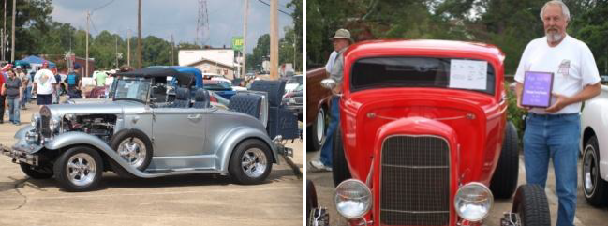

MAGEE CRAZY DAY CAR CLASSIC
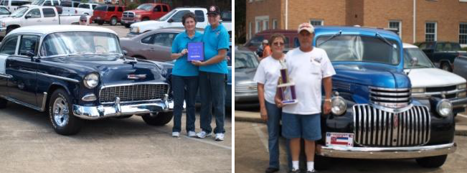

SATURDAY, OCTOBER 22, 2016
North Main Street
Take Hwy 541 North, then left on 3rd Street
Proceeds to Benefit Magee Chamber of Commerce

Registration: 7:30 – 9:30 | Categories: | Hot Rods | Cars–Classic
Fees – $20 |  | Rat Rod | Cars-Muscle era
Trophies Awarded @ 12:30 |  | Trucks-Classic | Cars-Modern
Voting: 9:30 – 12:00 |  | Sport/Import | Trucks-Modern
 |  | Best of Show

Door Prizes & Goody Bags
Call 601-849-2517
for more Details

Owner’s Name

Address

City State Zip

Phones Email

Vehicle(s) Year/Make/Category-#1_
#2
