MR. & MISS CRAZY DAY PAGEANT 2017
Sponsored by the Magee Chamber of Commerce
Directed by LauraLyn Barr and Erica Smith

Saturday, October 7, 2017 @ 2:00pm
Magee High School Auditorium
Admission: $5 (Children 4 and under free)
**Registration will be from 11:30 am - 1:30 pm.
If you have not checked in by 1:30 pm you will not be allowed to participate.

Fee:
Contestant Entry Fee: $30; Siblings 2 for $50
Entry Fee Deadline is September 29, 2017.
Checks payable to: Magee Chamber of Commerce

Additional $10 for those who wish to participate in the Photogenic division.
** Money/picture for Photogenic division can be turned in with registration form
or brought in on pageant day.

Age Divisions:
0-18 mths 10-12 years
19 mths-3 years 13-15 years
4-6 years 16-19 years
7-9 years Mrs. Division
Special Needs Division (Heart of Crazy Day 2017)
**We reserve the right to combine or cancel groups if not enough entries received by deadline.

Attire:
0-6 years: Sunday Best
7rs and up: Pageant Attire
Heart of Crazy Day: Sunday Best

Awards:
Winner and alternates will be chosen in each division.
Winner will receive a crown and sash.
Alternates will receive flowers.
Most Photogenic will receive flowers and sash.

People’s Choice Award:
This award will be voted on by the public on the day of the pageant. Cost is $1.00 Encourage all of your family and friends to vote for you for People’s Choice. The contestant with the MOST votes will be awarded Crazy Day People’s Choice 2017.
ONE winner overall will be chosen.

**Please mail or bring registration and entry fee to: Magee Chamber of Commerce 117 First Ave. Magee, MS 39111. For questions contact 601-849-2517 or commercechamber@bellsouth.net

2017 Mr. and Mrs. Crazy Day Parent Information:

In order for pageant to begin promptly at 2pm Check in on day of pageant will be from 1130-130. If you have not checked in by 130 you will be removed from pageant and will forfeit your entry fee.

Photographer will be available for day of pageant and will begin at 10:00am. Pictures may be purchased directly from photographer for varying prices.

There are NO changing rooms. Please come dressed and ready.

There will be a designated area for contestants to sit while awaiting their age group.

Parents will NOT be allowed backstage for children over the age of 9. NO EXCEPTIONS.

All judges decisions are final and score sheets will NOT be available for viewing.

Poor sportsmanship will NOT be tolerated.

Food and drinks are NOT ALLOWED in the facility.

The stage will be marked in the “Standard T” formation shown below. Please review this and practice with your child as there will be NO PRACTICE.
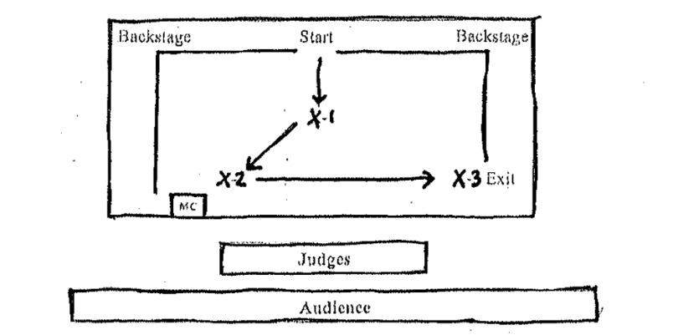

Pageant Winner Information:

There is a great POSSIBILITY that winners will make an appearance on WLBT – Midday, MS to promote Crazy Day 2017. Information regarding this will be provided to winners.

Winners will be introduced at Crazy Day on October 28, 2017 and are expected to attend.

Winners may participate in the Christmas Parade in December.

Crowns and Sashes are expected to be worn at all times during appearances promoting the pageant.

ALL winners are expected to participate as a GROUP in activities.

Mr. and Miss Crazy Day Pageant 2017 Entry Form

Please check if applicable ___Mrs. Division ___ Heart Of Crazy Day

Otherwise contestants will be placed in correct division based on birthdate.

Contestant Name_____________________________________

Age______ (at time of Pageant) DOB ___________________

Parent’s Name________________________________________

Hair Color___________ Eye Color____________

Favorite Food________________________________

Favorite TV show_____________________________

Hobbies______________________________________________________

Future Plans__________________________________________________

Why would you like to be chosen as “Mr. or Miss Crazy Day”

____________________________________________________________________________________________________________________________________

Rules, Regulations, and Agreement

By signing below I agree that the above information is true and correct to the best of my knowledge. I agree and will abide by all rules set forth by the director. I agree that I will hold harmless the director, host facility, and volunteers from any damages/loss/injury while traveling to event, during event, and following event. I agree that I/my child must compete in the correct age division. I also agree that poor sportsmanship will not be tolerated and could lead to disqualification from pageant. I understand and agree that judge’s decisions are final and scores are confidential. I understand that pageant may be cancelled due to lack of participation. Registration Fees are non refundable except in the event pageant is cancelled.

Applicant’s name______________________________________________________________

Signature _______________________________________________________ (parent or guardian)

Please provide an Email Address _______________________& Phone Number _____________________.

Please return completed form and payment to:
Magee Chamber of Commerce
117 First Avenue
Magee, MS 39111
DEADLINE FOR ENTRY IS SEPTEMBER 29, 2017.

PLEASE CONTACT 601-849-2517 OR commercechamber@bellsouth.net WITH QUESTIONS.

