MR. & MISS CRAZY DAY PAGEANT 2018
Sponsored by the Magee Chamber of Commerce

Saturday, September 22, 2018 @ 2:00pm
Magee High School Auditorium
Admission: $5 (Children 4 and under free)
**Registration will be from 12:00 pm. - 1:30 pm.
If you have not checked in by 1:30 pm you will not be allowed to participate.

Fees:
Contestant Entry Fee: $30; Siblings 2 for $50
Entry Fee Deadline is September 13, 2018.
Checks payable to: Magee Chamber of Commerce

Additional $10 for those who wish to participate in the Photogenic division.
** Money/picture for Photogenic division can be turned in with registration form
or brought in on pageant day.

Age Divisions:
0-18 mths 10-12 years
19 mths-3 years 13-15 years
4-6 years 16-19 years
7-9 years Mrs. Division
Special Needs Division (Heart of Crazy Day 2018)
**We reserve the right to combine or cancel groups if not enough entries received by deadline.

Attire:
0-6 years: Sunday Best
7rs and up: Pageant Attire
Heart of Crazy Day: Sunday Best
** Contestants will be judged on adherence to attire guidelines in addition to other categories.

Awards:
Winner and alternates will be chosen in each division.
Winner will receive a crown and sash.
Alternates will receive flowers.
Most Photogenic will receive flowers and sash.

People’s Choice Award:
This award will be voted on by the public on the day of the pageant. Cost is $1.00 per vote. Encourage all of your family and friends to vote for you for People’s Choice. The contestant with the MOST votes will be awarded Crazy Day People’s Choice 2018.
ONE winner overall will be chosen.

**Please mail or bring registration and entry fee to: Magee Chamber of Commerce 117 First Ave. Magee, MS 39111. For questions contact 601-849-2517 or commercechamber@bellsouth.net

2018 Mr. and Miss Crazy Day Parent Information:

REFUSAL TO COMPLY WITH ANY OF THE RULES LISTED BELOW WILL RESULT IN YOUR CHILD BEING REMOVED FROM THE PAGEANT AND FORFEITURE OF ENTRY FEE.

In order for pageant to begin promptly at 2pm check in on day of pageant will be from 12-130. If you have not checked in by 130 you will be removed from pageant and will forfeit your entry fee.

There are NO changing rooms. Please come dressed and ready.

There will be a designated area for contestants to sit while awaiting their age group.

Beginning at 130pm parents will NOT be allowed backstage for children over the age of 9. NO EXCEPTIONS. There is very little room backstage and overcrowding is an issue. There will be people backstage to assist your child if needed.

All judges decisions are final and score sheets will NOT be available for viewing.

Poor sportsmanship will NOT be tolerated.

Food and drinks are NOT ALLOWED in the facility.

The stage will be marked in the “Standard T” formation shown below. Please review this and practice with your child as there will be NO PRACTICE.
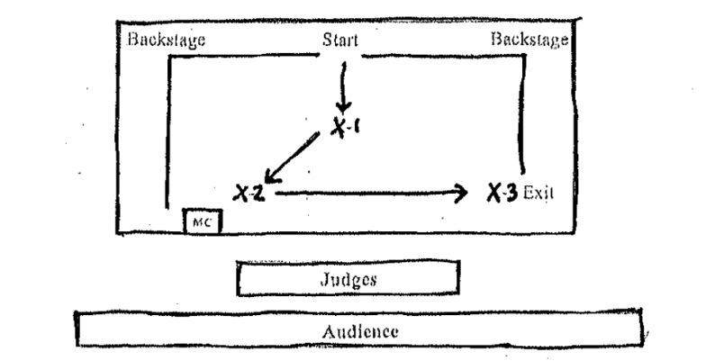

Pageant Winner Information:

There is a POSSIBILITY that winners will make an appearance on WLBT – Midday, MS to promote Crazy Day 2018. Information regarding this will be provided to winners.

Winners will be introduced at Crazy Day on October 27, 2018 and are expected to attend.

Winners may participate in the Christmas Parade in December if so desire.

Crowns and Sashes are expected to be worn at all times during appearances promoting the pageant.

ALL winners are expected to participate as a GROUP in activities.

Mr. and Miss Crazy Day Pageant 2018 Entry Form

Please check if applicable ___Mrs. Division ___ Heart Of Crazy Day

Otherwise contestants will be placed in correct division based on birthdate.

Contestant Name__________________________________________________

Age______ (at time of Pageant) DOB ________________________________

Parent’s Name____________________________________________________

Hair Color____________________ Eye Color__________________________

Favorite Food____________________________________________________

Favorite TV show_________________________________________________

Hobbies________________________________________________________

Future Plans____________________________________________________

Why would you like to be chosen as “Mr. or Miss Crazy Day”

____________________________________________________________________________________________________________________________________

Rules, Regulations, and Agreement

By signing below I agree that the above information is true and correct to the best of my knowledge. I agree and will abide by all rules set forth by the directors. I agree that I will hold harmless the director, host facility, and volunteers from any damages/loss/injury while traveling to event, during event, and following event. I agree that I/my child must compete in the correct age division. I also agree that poor sportsmanship will not be tolerated and could lead to disqualification from pageant. I understand and agree that judge’s decisions are final and scores are confidential. I understand that pageant may be cancelled due to lack of participation. Registration Fees are non refundable except in the event pageant is cancelled.

Applicant’s name_______________________________________________________________________________

Signature _______________________________________________________ ____________(parent or guardian)

Please provide an Email Address ___________________________________Phone Number ___________________.

Please return completed form and payment to:
Magee Chamber of Commerce
117 First Avenue
Magee, MS 39111
DEADLINE FOR ENTRY IS SEPTEMBER 13, 2018.

PLEASE CONTACT 601-849-2517 OR commercechamber@bellsouth.net WITH QUESTIONS.

