MISS CRAZY DAY PAGEANT 2022

Saturday, October 22, 2022 @ 10:00am
Magee Civic Center
Admission: $5 (Children 5 and under free)
**Registration will be from 9:00 am. – 9:45 am.
If you have not checked in by 9:45 pm you will not be allowed to participate.

Fees:
Contestant Entry Fee: $35
Optional: Photogenic - $10
Fashion - $5
Total for ALL categories $50
Entry Fee Deadline is October 12, 2022.
Checks payable to: Deitra Wheat

Additional $10 for those who wish to participate in Photogenic & additional $5 for Fashion
** Picture for Photogenic competition can be turned in with registration form
or emailed to dwheat78@gmail.com

Age Divisions:
0-11 months 7-9 years
12-23 months 10-12 years
2-3 years 13-15 years
4-6 years 16-18 years

**We reserve the right to combine or cancel groups if not enough entries received by deadline.

Attire:
Pageant Attire
** Contestants who need to rent a dress for the pageant, Mrs. Deitra Wheat is offering a special discounted price for ALL contestants

Awards:
Queen, Princess and 3 alternates will be chosen in each division.
Queen & Princess will receive a crown and sash.
Alternates will receive a sash
Most Photogenic & Best Fashion will receive a crown

People’s Choice Award:
This award will be voted on by the public on the day of the pageant. Cost is $1.00 per vote. Encourage all of your family and friends to vote for you for People’s Choice. The contestant with the MOST votes will be awarded Crazy Day People’s Choice 2022 and receive a beautiful round crown that will be displayed at the front table for everyone to view.
ONE winner will be chosen.

**Please mail the entry form and fee to: Deitra Wheat, 2833 SCR 18 Mize, MS 39116 For any questions contact: Deitra Wheat @ 601-953-7558 or dwheat78@gmail.com

2022 Miss Crazy Day Parent Information:

REFUSAL TO COMPLY WITH ANY OF THE RULES LISTED BELOW WILL RESULT IN YOUR CHILD BEING REMOVED FROM THE PAGEANT AND FORFEITURE OF ENTRY FEE.

In order for pageant to begin promptly at 10am check in on day of pageant will be from 9:00 -9:45. If you have not checked in by 9:45 you will be removed from pageant and will forfeit your entry fee.

There will be changing areas for the contestants and only 1 “helper” per contestant.

There will be a designated area for contestants to sit while awaiting their age group.

All judges decisions are final and score sheets will NOT be available for viewing.

Poor sportsmanship will NOT be tolerated.

Food and drinks are NOT ALLOWED in the facility.

If any checks are returned, you will be responsible for the returned check fee and your child will not be eligible to compete unless it is all cleared by the deadline.

The stage will be marked in the “Standard T” formation shown below. Please review this and practice with your child as there will be NO PRACTICE.
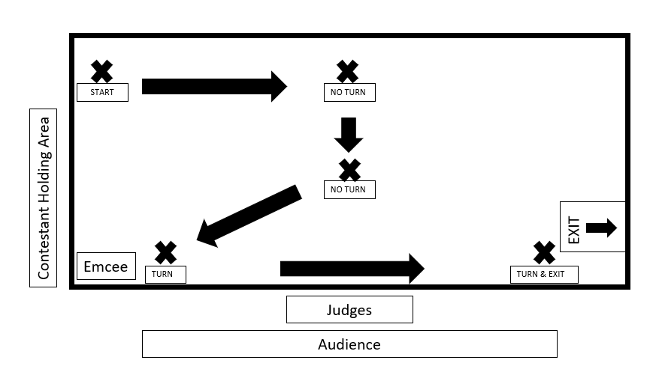

Pageant Winner Information:

Winners will be introduced at Crazy Day @ 2 p.m. on the Main Stage located on Main Street.
Winners are expected to attend.
Crowns and Sashes are expected to be worn at all times during appearances promoting the pageant.

